Kyushu Institute of Technology

Department of Applied Science for Integrated System Engineering



**BIRDS-4 Project**

**FM satellite Battery charging procedure**

Laboratory of Lean Satellite Enterprises and In-Orbit Experiments



|  |  |  |  |
| --- | --- | --- | --- |
| **Date** | **Revision Number** | **Writer** | **Annotations** |
| 2020/08/29 | 1 | Izrael Zenar Bautista, Marloun Sejera, Yigit Cay | Initial release |
| 2020/09/08 | 1.1 | Izrael Bautista | Added steps and re-ordered some numbers |
|  |  |  |  |

# Introduction

During the satellites’ storage inside cleanroom before hand-over to JAXA, the satellites were charged in order to have high state-of-charge before delivery to JAXA.. This document discusses the procedure for charging the satellites.

Shown below is the schematic diagram of the battery charging using the external power supply. The satellites are charged using an external power supply. The deployment switches (SW1, SW2 and SW3) are normally closed switches. When SW1 and SW2 are not pressed, they allow the MOSFET switches (SepSW1, SepSW2 and SepSW3) to conduct. When inserted, Remove Before flight (RBF) PIN 1 disconnects the load from the source (solar cells and battery) while RBF PIN 2 disconnects the battery negative terminal from the system ground. To allow charging of the battery, RBF PIN 2 must be removed.

# 1.1 Battery charging overview

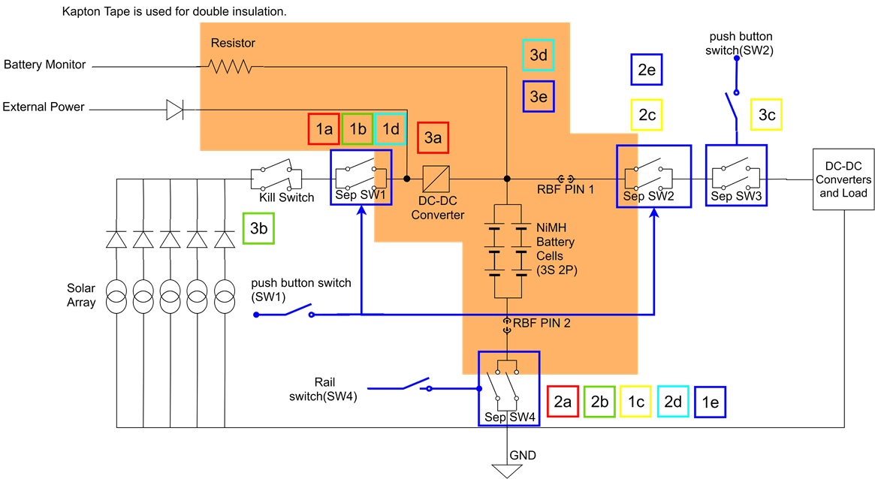

Rail Switch (SW3)

In the battery charging process, one DC power supply is connected to one satellite as in the figure below. The satellites will be charged one-at-a-time to ensure proper charging of the satellites.

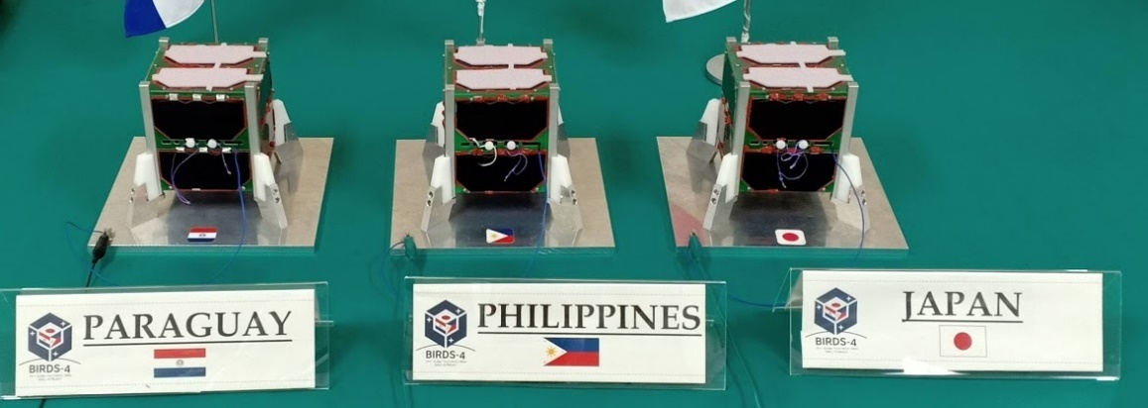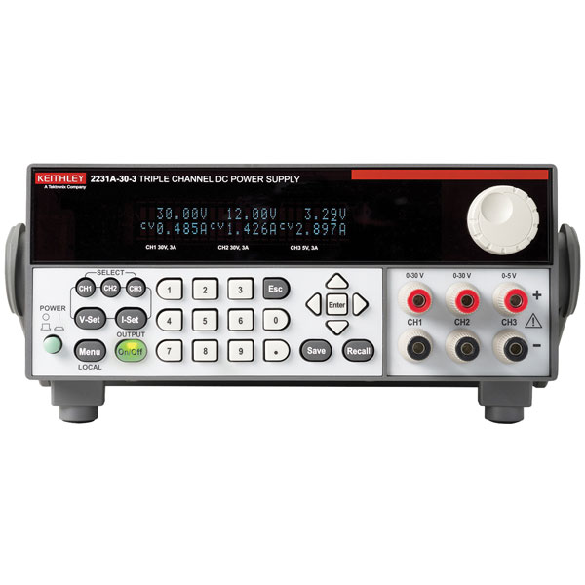





Battery charging procedure

0) Personnel doing this procedure must have proper rest (more than 6 hours sleep), not hungry (has eaten for the past 2 hours) and no other commitments for the duration of charging (approx. 6 hours). Wear ground straps and connect to grounding cable near the table

1. Prepare power supply. Set voltage output to 5.2V,0.8A.
2. Remove GND connector from satellite
3. Put Kapton tape on satellite bottom deployment switches.
4. Measure the battery voltage and record. **Refer to Battery voltage Measurement procedure**
5. Place charging pin to satellite. Be careful not to interchange (+) and (-) pins
6. Double check the connection with another person
7. Turn ON the output of the power supply. You should see [5.2V, ~0.020 A]. This means that the connection is good.
8. Remove ONLY RBF-2 of satellite.
9. Check the current of power supply. It should increase.
10. Do not leave the satellite while it is being charged. Monitor the charging current. It should decrease slowly. If any unusual event happens (current fluctuates too much, rapid decrease of charging current, etc.), stop charging (see step #12-14) and report to senseis.
11. Once the charging current reaches 0.060A or when the charging current does not decrease after 15 minutes, the satellite is in fully charge state.
12. Insert the RBF-2.
13. Turn-OFF power supply
14. Remove charging cable
15. Measure the battery voltage again as in step #4 and record. Battery voltage should be around 4.1 - 4.2V.
16. Put GND cable in charging port.
17. Remove Kapton tape from satellite bottom deployment switches
18. Repeat steps #2-17 for the next satellite.
19. Once all satellites are finished, re-check if all Kapton tape are removed, GND connector properly inserted and power supply is turned OFF

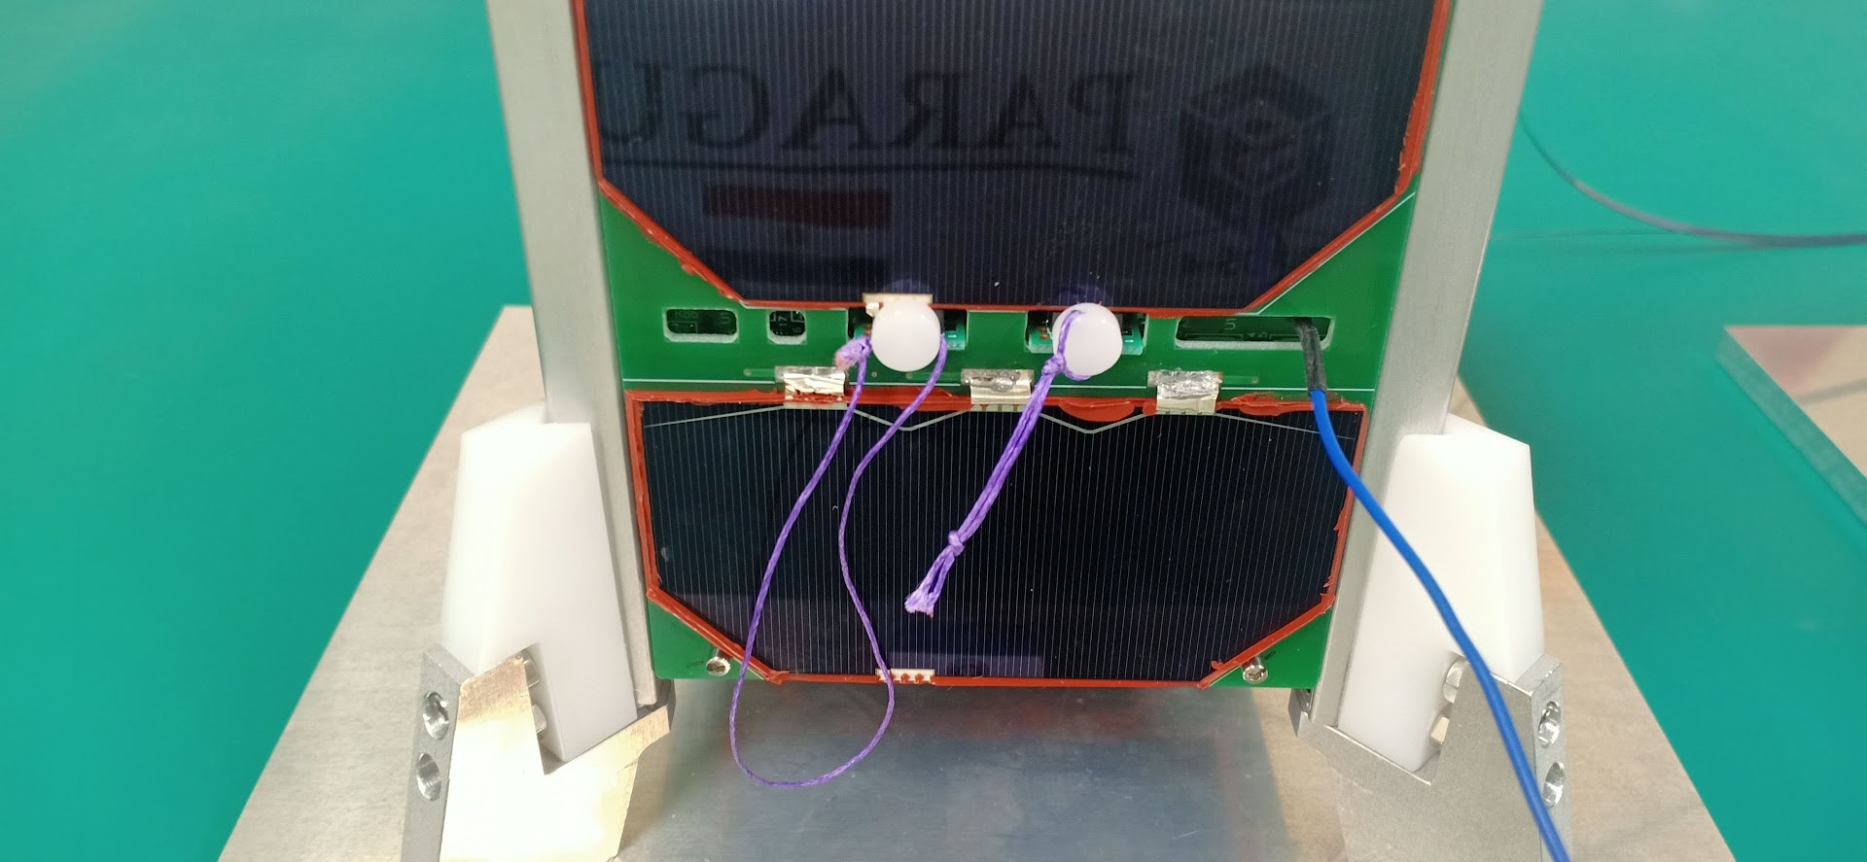

RBF1-**DO NOT remove** for charging

RBF2-remove for charging

|  |  |  |  |  |  |
| --- | --- | --- | --- | --- | --- |
| Step | Action | Guara-  nisat | Maya-2 | Tsuru | Remarks |
| 0 | Personnel doing this procedure must have proper rest (more than 6 hours sleep), not hungry (has eaten for the past 2 hours) and no other commitments for the duration of charging (approx. 6 hours). Wear ground straps and connect to grounding cable near the table |  |  |  |  |
| 1 | Prepare power supply. Set voltage output to 5.2V,0.8A. |  |  |  |  |
| 2 | Remove GND connector from satellite |  |  |  |  |
| 3 | Put Kapton tape on satellite bottom deployment switches. |  |  |  |  |
| 4 | Measure the battery voltage and record. **Refer to Battery voltage Measurement procedure** |  |  |  |  |
| 5 | Place charging pin to satellite. Be careful not to interchange (+) and (-) pins |  |  |  |  |
| 6 | **Double check the connection with another person** |  |  |  |  |
| 7 | Turn ON the output of the power supply. You should see [5.2V, ~0.020 A]. This means that the connection is good. |  |  |  |  |
| 8 | Remove **ONLY RBF-2** of satellite. |  |  |  |  |
| 9 | Check the current of power supply. It should increase. |  |  |  |  |
| 10 | **Do not leave the satellite while it is being charged.**  **Monitor the charging current. It should decrease slowly.**  **If any unusual event happens (current fluctuates too much, rapid decrease of charging current, etc.), stop charging (see step #12-14) and report to senseis.** |  |  |  |  |
| 11 | Once the charging current reaches 0.060A or when the charging current does not decrease after 15 minutes, the satellite is in fully charge state. |  |  |  |  |
| 12 | Insert RBF-2 |  |  |  |  |
| 13 | Turn-OFF power supply |  |  |  |  |
| 14 | Remove charging cable |  |  |  |  |
| 15 | Measure the battery voltage again as in step #4 and record. **Battery voltage should be around 4.1 - 4.2V.** |  |  |  |  |
| 16 | Put GND cable in charging port. |  |  |  |  |
| 17 | Remove Kapton tape from satellite bottom deployment switches |  |  |  |  |
| 18 | Repeat steps #2-17 for the next satellite. |  |  |  |  |
| 19 | Once all satellites are finished, re-check if all Kapton tape are removed, GND connector properly inserted and power supply is turned OFF |  |  |  |  |